1. Open Eclipse IDE.
2. Open “**Help**” ***menu*** and click on “**Eclipse Marketplace…**”

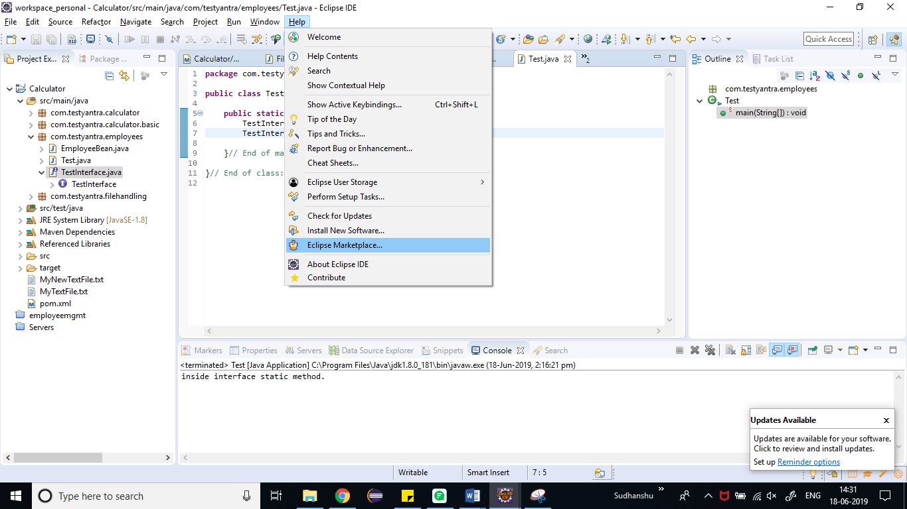

1. *Search for* **Sonarlint** and click on “**Install**” button –

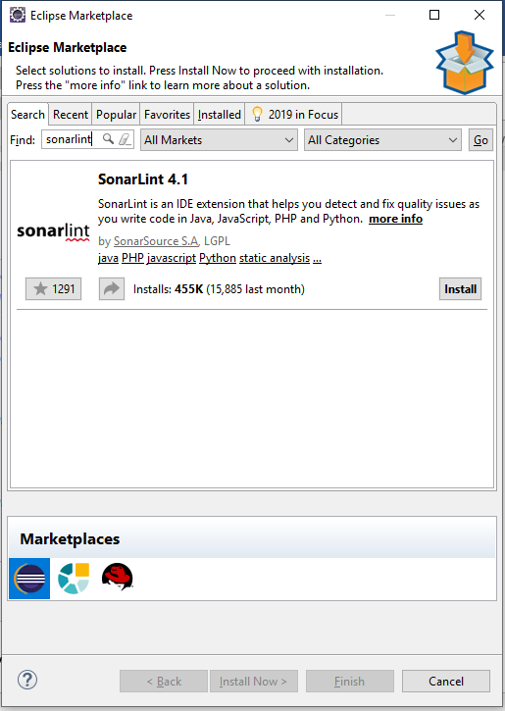

1. ***Accept the License Agreement*** and click on “**Finish**” button –

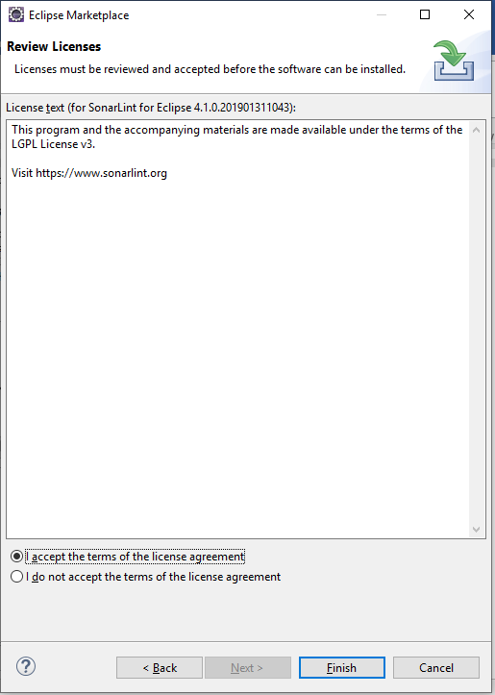

1. Let the Installation complete –

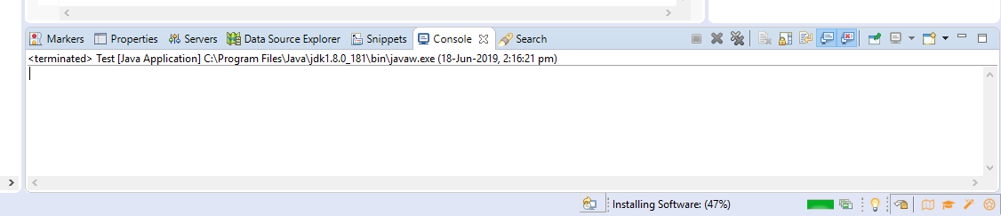

1. ***RESTART the Eclipse –***

